Nicola Hetrick

Kira Combs

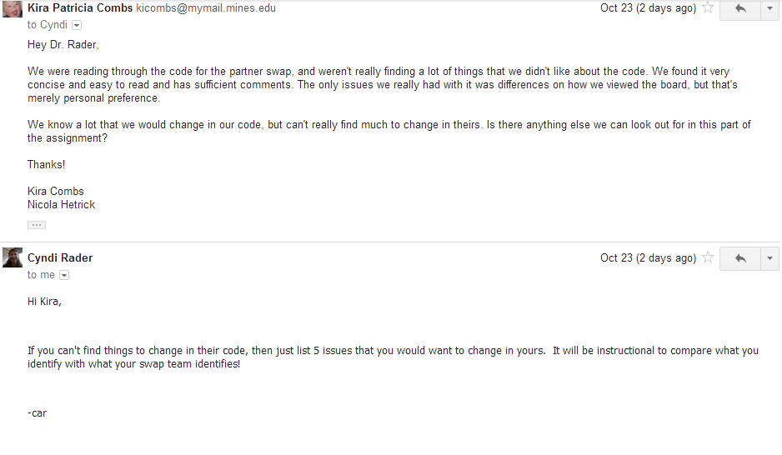

1) We want to find a way to merge out clearListsAndSetToFalse() function into the other functions so we don’t have to call it continuously in the tests. One possible solution: create a calcTargetsRecursively() function that is called by calcTargets() and then reset the board(clearListsAndSetToFalse()) before the calcTargetsRecursively() function is called.

2) For convenience, we’d want to add a function that takes an index and spouts out a coordinate (basically a function that undo’s the calcIndex function)

3) For neatness, use switch statements instead of multiple if statements in functions like saveCellInformation(When dealing with door direction) and calcAdjacencies

4) a simpler way of passing the file name (for example setting the file in the creation of Board so the name only has to be changed in one location rather than two locations in our loadConfigFiles function)

5) Close our scanner and our files after we are done with them